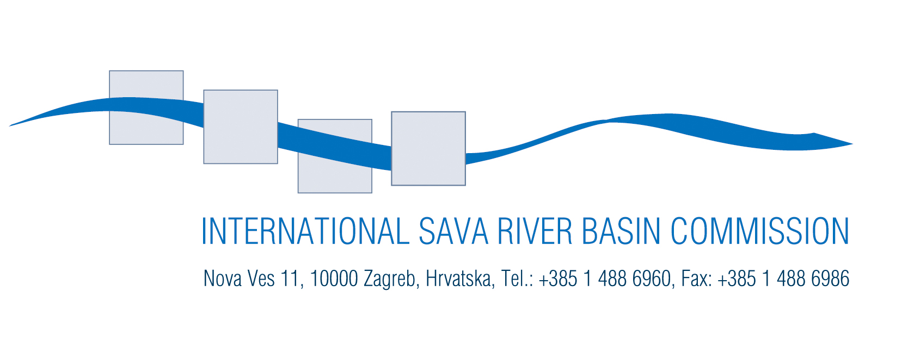

Ref. No.:3-08-3/2-2-PEG.1

Zagreb, March 11, 2008

Draft AGENDA 3. March 2008
7th Sava PEG RBM Meeting
Zagreb, Croatia – March 11-12, 2008

(Start at 11:00 on March 11; end at 16:00 on March 12)

1. Opening of the meeting
- Welcome by the Chairman
- Adoption of the Agenda
- Brief report on activities performed between 6th and 7th PEG RBM meeting
2. Adoption of the report of the 6th PEG RBM meeting
3. Sava RB Analysis Report
- Water quality chapter
  - Final report by the Sava CARDS project
  - Gaps and further steps
- Water quantity issues
- Countries’ presentations on performed activities
- Further steps and timeline
- Flood management
  - Information on PEG FP SRBA related activities
- Mapping needs for the Sava RBA report
- Presentation of already collected GIS data
- Presentation of the initial list of maps
- Other SRBA activities
- Terms of reference for hydrology
4. SRBM Plan
- Sava RBM Plan project proposal
- Information on project status
- Data collection activities
- Information on joint ICPDR-ISRBC data collection proposal
5. Cooperation and Projects
- Sava CARDS project
  - Sava CARDS supporting activities –final report

6. Sava information system
- Database on stakeholders and projects
  - Sava CARDS final report
  - Information on PEG NAV activities
7. RBM Work plan and programme for FY 2008
- Work plan and programme for FY 2008-discussion and adoption
8. Protocols
- Protocol on transboundary impacts
  - preparation of Annex I of the Protocol
9. Any other issue

